Contacts and Reports Manager

User Manual

Contents

[Overview 4](#_Toc340864601)

[Contacts 4](#_Toc340864602)

[Departments 4](#_Toc340864603)

[Reports 4](#_Toc340864604)

[Settings 4](#_Toc340864605)

[The Interface 5](#_Toc340864606)

[The Tab Pane 5](#_Toc340864607)

[The List Pane 5](#_Toc340864608)

[The Details Pane 5](#_Toc340864609)

[About Buttons 5](#_Toc340864610)

[Create 5](#_Toc340864611)

[Delete 6](#_Toc340864612)

[Edit 6](#_Toc340864613)

[Cancel 6](#_Toc340864614)

[Save 6](#_Toc340864615)

[Preview 6](#_Toc340864616)

[Send 6](#_Toc340864617)

[Add 6](#_Toc340864618)

[Remove 6](#_Toc340864619)

[The Contacts Tab 7](#_Toc340864620)

[About Contacts 7](#_Toc340864621)

[Full Name 7](#_Toc340864622)

[Job Title 7](#_Toc340864623)

[Work Phone 7](#_Toc340864624)

[Home Phone 7](#_Toc340864625)

[Work Address 7](#_Toc340864626)

[Home Address 7](#_Toc340864627)

[E-mail 7](#_Toc340864628)

[Birthday 7](#_Toc340864629)

[Working with Contacts 8](#_Toc340864630)

[Creating a New Contact 8](#_Toc340864631)

[Editing an Existing Contact 8](#_Toc340864632)

[Deleting a Contact 9](#_Toc340864633)

[The Departments Tab 10](#_Toc340864634)

[About Departments 10](#_Toc340864635)

[Department Name 10](#_Toc340864636)

[Department Phone 10](#_Toc340864637)

[Department Address 10](#_Toc340864638)

[Employees 10](#_Toc340864639)

[Working with Departments 10](#_Toc340864640)

[Creating a New Department 10](#_Toc340864641)

[Editing an Existing Department 11](#_Toc340864642)

[Deleting a Department 11](#_Toc340864643)

[The Reports Tab 12](#_Toc340864644)

[About Reports 12](#_Toc340864645)

[Report Title 12](#_Toc340864646)

[Start Date 12](#_Toc340864647)

[End Date 12](#_Toc340864648)

[Dimensions 12](#_Toc340864649)

[Metrics 13](#_Toc340864650)

[Sort 13](#_Toc340864651)

[Filter 13](#_Toc340864652)

[Maximum Results 13](#_Toc340864653)

[Recipients 13](#_Toc340864654)

[Working with Reports 14](#_Toc340864655)

[Creating a New Report 14](#_Toc340864656)

[Editing an Existing Report 14](#_Toc340864657)

[Deleting a Report 14](#_Toc340864658)

[Previewing a Report 15](#_Toc340864659)

[Sending a Report 15](#_Toc340864660)

[The Settings Tab 16](#_Toc340864661)

[Troubleshooting 17](#_Toc340864662)

[Appendix A 18](#_Toc340864663)

[Dimensions 18](#_Toc340864664)

[Metrics 22](#_Toc340864665)

# **Overview**

The Contact and Report Manager, hereafter referred to as the “the program,” provides a unified interface for working with information stored on a database server. The program allows creating, viewing, editing, and deleting entries in a specified database. The program is designed to manage three distinct pieces of the business process:

## Contacts

Users can view all of the employees associated within their company, as well as other frequent contacts who may not be employed by the company. Basic information is stored for each contact, such as job title, work and home phone numbers, email address, and birthday. Additionally, new contacts can be created and saved, and existing contacts can be modified or deleted.

## Departments

As with employees and other contacts, users can view all of the departments within their company. The details stored with a department are the department title, phone number, mailing address, along with a list of all of the employees inside that department.

## Reports

Report management is a powerful feature of the program which provides users with an intuitive interface for working with reports from Google Analytics. Google Analytics, a website analysis and tracking tool provided by Google Inc., can return results based on many unique queries. The program allows users to easily request such results for a specified report format, as well as save the profile of the report for later use. Once saved, the report profile can be modified or deleted.

## Settings

The settings tab is designed to give a user-friendly interface for editing settings and properties. Users should specify the location of their database and Simple Mail Transfer Protocol (SMTP) server, as well as the username and password used for authentication when communicating with these external servers. All settings can be edited at any time; although, the program may not function correctly if a setting is invalid.

# The Interface

The program interface is simple and intuitive, while still providing all of the desired functionality and features. When the program is running, the user is presented with a single window with multiple tabs along the side. All of the program operations are performed in this window by selecting the appropriate tab and using the two panes that are displayed in the right side of the program window.

## The Tab Pane

The tab pane displays the four primary tabs: Contacts, Departments, Reports, and Settings. Selecting a tab will update the right side of the screen with the contents of that tab.

## The List Pane

The list pane is a searchable list of all of the information found in the database. While using the Contacts tab, the list pane will show all of the saved contacts; while using the Departments tab, the list pane will display all of the departments. Likewise, it will show the saved report profiles when in the Reports tab.

## The Details Pane

The details pane focuses solely on the content important to the user. For this reason, the details pane takes the majority of the program’s display. A selected item in the list pane will populate the details pane with all of the information stored with that selection. This is where the information such as a contact’s work phone number or birthday, or a department’s mailing address, or any other useful data can be found.

Not only is the details pane used for viewing, but it is also used for changing information. The inline editor provides a convenient way to change the data associated with a contact, department, or saved report profile. These two distinct modes are frequently referred to as view mode and edit mode.

## About Buttons

There are several different buttons that the user can select while using the program. The location of the buttons is contextual. For example, to operate on the list pane, use the buttons on the bottom of the list pane. To operate on the details pane, use the buttons on the bottom of the details pane. A brief description of each button is provided below.

### H:\EECS448\Project3+\EECS448_Project1\src\resources\images\plus.pngCreate

The “Create” button appears at the bottom of the list pane. It allows the user to create a new item that will be saved to the database and added to the list. Not available in edit mode.

### H:\EECS448\Project3+\EECS448_Project1\src\resources\images\delete.pngDelete

The “Delete” button appears at the bottom of the list pane. It allows the user to permanently delete the selected item from the database and list. Not available in edit mode.

### H:\EECS448\Project3+\EECS448_Project1\src\resources\images\pencilTiny.pngEdit

The “Edit” button appears at the bottom of the details pane when in view mode. It allows the user to edit the details displayed for the currently selected item. Not available in edit mode.

### H:\EECS448\Project3+\EECS448_Project1\src\resources\images\thumbsDownTiny.pngCancel

The “Cancel” button appears at the bottom of the details pane when in edit mode. It reverts any changes made to the current item being edited. Not available in view mode.

### H:\EECS448\Project3+\EECS448_Project1\src\resources\images\save.pngSave

The “Save” button appears at the bottom of the details pane when in edit mode. It saves all updated information for the current item to the database. Not available in view mode.

### H:\EECS448\Project3+\EECS448_Project1\src\resources\images\loadTiny.pngPreview

The “Preview” button appears at the bottom of the details pane while in the Reports tab. It submits the request for a Google Analytics report using the user-specified fields in the currently selected report profile. The results will appear in a pop-up window but not be sent. Available in view or edit mode in the Reports tab.

### H:\EECS448\Project3+\EECS448_Project1\src\resources\images\mailTiny.pngSend

The “Send” button appears at the bottom of the details pane while in the Reports tab. It submits the request for a Google Analytics report just as the “Preview” button does. However, the results can also be sent by email to the specified recipients in the report profile.

### Add

The “Add” button appears in the details pane while editing departments or reports. It is used to add contacts or departments to a list, such as adding employees to a department.

### Remove

The “Remove” button appears alongside “Add.” It will remove selected items from the list. Unlike “Delete,” removing an item such as a contact does not delete the contact from the database.

# The Contacts Tab

## About Contacts

A contact is a generic term for any individual whose information will be stored in the database, including both employees and non-employees. The details that may be stored for a contact are:

### Full Name

The contact’s first and last name only, separated by a space. For example, “John Doe” would be a valid entry.

### Job Title

The job title of the contact.

### Work Phone

The contact’s phone number for work.

### Home Phone

The contact’s home phone number.

### Work Address

The mailing address of the contact’s work.

### Home Address

The mailing address of the contact’s home.

### E-mail

An electronic mailing address at which the contact may be reached.

### Birthday

The birthday of the contact, in format of MMM d. The year is not saved. For example, “Mar 3” and “Nov 25” would be valid entries.

Aside from the contact’s name, any field may be left blank, but it is recommended that users provide as much information as possible.

*Note*: A contact’s full name **must** be given in order for the contact to be saved.

## Working with Contacts

There are three primary operations associated with contacts: Create, Edit, and Delete.

Creating a contact adds a new entry in the database and allows users to view the contact’s information at any time by selecting the contact in the list pane.

Editing a contact changes the information saved with an existing contact.

Deleting a contact removes the entry for the contact from the database permanently.

### Creating a New Contact

1. Select the Contacts tab from the tab pane on the left side of the window.
2. Click the H:\EECS448\Project3+\EECS448_Project1\src\resources\images\plus.png (“Create”) button at the bottom of the list pane. The details pane on the rightmost side of the window will update to display a blank template for a new contact.

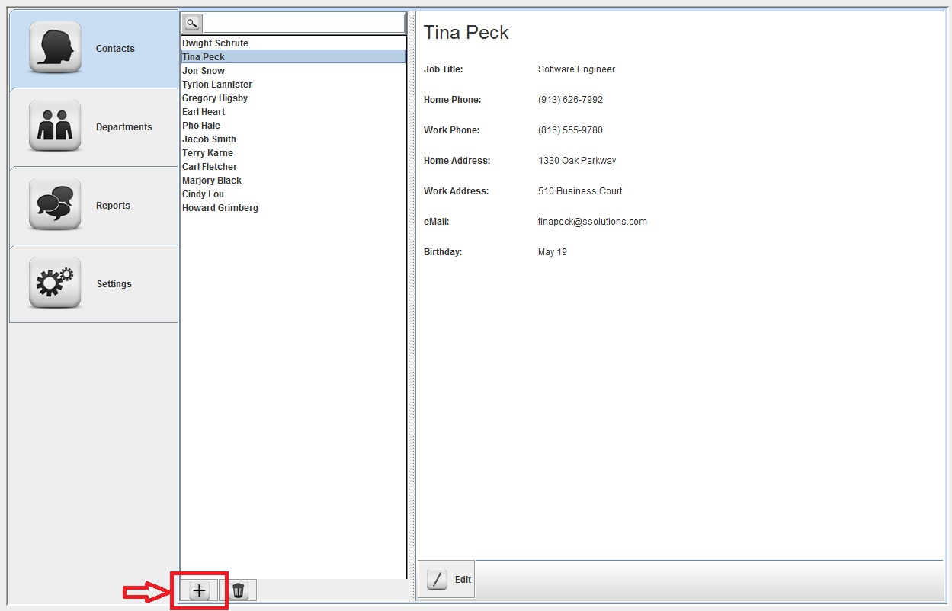

Figure 1

1. Enter the full name for the contact and any other applicable information such as job title, home/work phone numbers, home/work addresses, e-mail address, and birthday in the appropriate fields. Leave other fields blank.
   1. The full name must be given in order to save the contact.
   2. A red field indicates an invalid value. The contact cannot be saved until these errors have been resolved.
   3. Clicking the H:\EECS448\Project3+\EECS448_Project1\src\resources\images\save.png (“Save”) button at the bottom of the details pane while red fields are present will provide a message detailing all of the errors in the form.
2. Click the H:\EECS448\Project3+\EECS448_Project1\src\resources\images\save.png (“Save”) button at the bottom of the details pane. If no errors are present, the contact will be saved in the database, and the details pane will change back to viewing mode with the new contact selected.

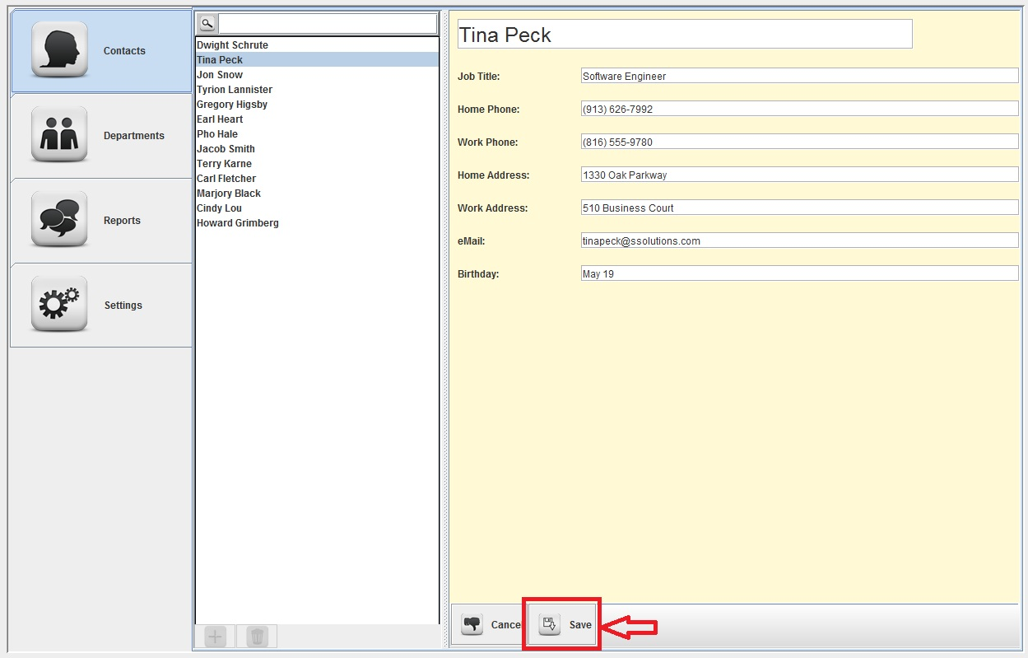

Figure 2

*Note*: The new contact may be discarded at any time by clicking the H:\EECS448\Project3+\EECS448_Project1\src\resources\images\thumbsDownTiny.png (“Cancel”) button.

### Editing an Existing Contact

1. Select the Contacts tab from the tab pane on the left side of the window.
2. Select the desired contact to edit from the list of contacts in the list pane.
3. Click on the H:\EECS448\Project3+\EECS448_Project1\src\resources\images\pencilTiny.png (“Edit”) button on the bottom of the details pane on the rightmost side of the window. All of the contact’s fields will become editable.

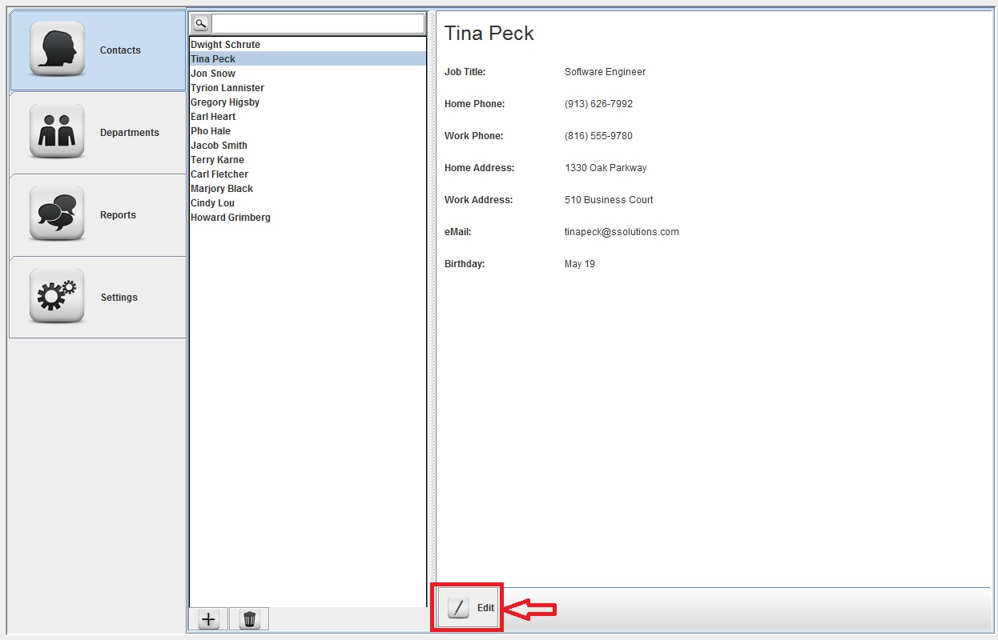

Figure 3

1. Edit the desired fields.
   1. A red field indicates an invalid value. The contact cannot be updated until these errors have been resolved.
   2. Clicking the H:\EECS448\Project3+\EECS448_Project1\src\resources\images\save.png (“Save”) button at the bottom of the details pane while red fields are present will provide a message detailing all of the errors in the form.
2. To save the updated information, click the H:\EECS448\Project3+\EECS448_Project1\src\resources\images\save.png (“Save”) button at the bottom of the details pane**.** If no errors are present, the contact’s information will be updated in the database, and the details pane will change back to viewing mode.
3. To discard all changes, click the H:\EECS448\Project3+\EECS448_Project1\src\resources\images\thumbsDownTiny.png (“Cancel”) button located at the bottom of the details pane. None of the changes will be saved, and the details pane will return to viewing mode, displaying the original contact information.

### Deleting a Contact

Not yet implemented.

# The Departments Tab

## About Departments

A department is a subgroup of employees within the company. Any contact may be added to a department, and contacts may appear in multiple departments. The details that may be stored for a department are:

### Department Name

The title of the department, such as “Marketing.”

### Department Phone

The phone number for the department.

### Department Address

The mailing address of the department.

### Employees

The list of employees that are in the department. Any contact may be added to a department.

It is recommended that users provide as much information as possible.

*Note*: The department name **must** be given for the department to be saved. Also, department **must** have at least one employee to be saved.

## Working with Departments

There are three primary operations associated with departments: Create, Edit, and Delete.

Creating a department adds a new entry in the database and allows users to view the department’s information at any time by selecting the department in the list pane.

Editing a department changes the information saved with an existing department.

Deleting a department removes the entry for the department from the database permanently.

Departments include the functionality to add and remove contacts from the department, referred to as “Employees” once associated with a department. However, contacts can only be selected from the list of contacts shown in the Contacts tab; a contact cannot be created while creating or editing a department.

### Creating a New Department

1. Select the Departments tab from the tab pane on the left side of the window.
2. Click the H:\EECS448\Project3+\EECS448_Project1\src\resources\images\plus.png (“Create”) button at the bottom of the list pane. The details pane on the rightmost side of the window will update to display a blank template for a new department.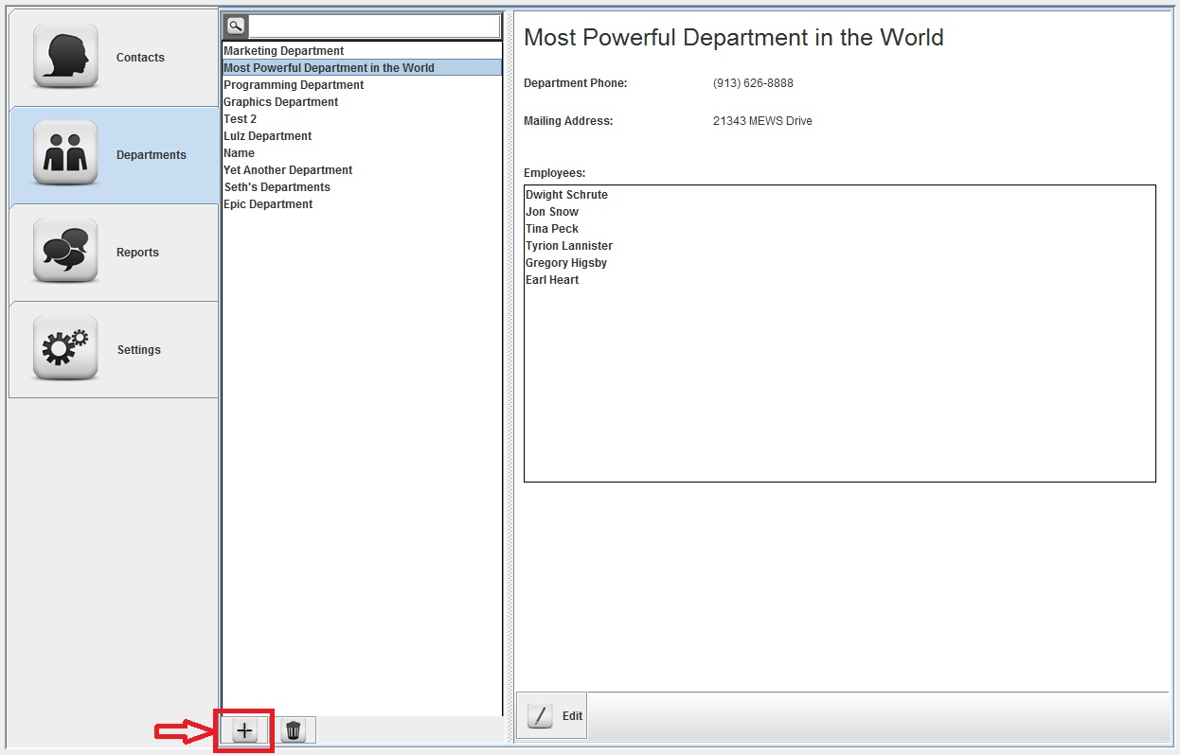

Figure 4

1. Enter the name of the department and any other desired information.
   1. A red field indicates an invalid value. The department cannot be saved until these errors have been resolved.
   2. Clicking the H:\EECS448\Project3+\EECS448_Project1\src\resources\images\save.png (“Save”) button at the bottom of the details pane while red fields are present will provide a message detailing all of the errors in the form.
2. Click the “Add” button beneath the empty list of employees. This will display a pop-up window with a list of available contacts.
3. Select all of the contacts that should be associated with the department. A department must have at least one employee.  
   *Tip*: To select multiple employees, hold down the CTRL or Shift buttons.
4. Click “Ok.”
5. Click the H:\EECS448\Project3+\EECS448_Project1\src\resources\images\save.png (“Save”) button at the bottom of the details pane. If no errors are present, the department will be saved in the database, and the details pane will change back to viewing mode with the new department selected.  
   *Note*: The new department may be discarded at any time by clicking the H:\EECS448\Project3+\EECS448_Project1\src\resources\images\thumbsDownTiny.png (“Cancel”) button.

### Editing an Existing Department

Not yet implemented.

### Deleting a Department

Not yet implemented.

# The Reports Tab

## About Reports

A report is a two-stage process involving user input and program output using data supplied by Google Analytics.

The first piece of a report is its profile, or format. This is a collection of settings specific to that report. Examples include the title, start and end dates, sorting and filtering options, and other user-specified fields. All fields are listed below.

The second part of the reporting process is the results stage. In this stage, a report’s profile is used to generate a request to Google Analytics, which yields the results. It is understood that operations involving creating and modifying a report’s settings operate on a report’s profile, and sending or previewing a report is an operation on the report’s results. For this reason, both steps of the process may be referred to cumulatively as a “report,” depending on the context.

### Report Title

The name of the report.

### Start Date

The beginning date of the report, in the format YYYY-MM-dd (2012-10-28). When querying Google Analytics, no results will be returned if they are earlier than the given start date. As an example, consider a report that gets the number of visitors to the company website since the beginning of August 2012. The start date should be set to 2012-08-01.

### End Date

The end date of the report, in the format YYYY-MM-dd (2012-11-08). When querying Google Analytics, no results will be returned if they are later than the given end date. Consider the example from the “Start Date” section. If the report were to be modified to only show the visitors during the month of August 2012, the end date would be 2012-08-31.

As a convenience, both the start and end date fields include a pop-up calendar for visually selecting the date. Click on the calendar icon next to the field to activate the date chooser.

### Dimensions

The list of all available dimensions that may be added to the report. When a dimension is selected, it will create a new column in the report’s results which will show the data for that dimension. For example, to determine the number of times a visitor has been to the website, select the dimension “ga:visitCount” and a column showing the visit count will be added to the results. Dimensions may also be used for sorting and filter. A complete list of available dimensions and their descriptions is in Appendix A.

### Metrics

The list of all available metrics that may be added to the report. When a metric is selected, it will create a new column in the report’s results which will show the data for that metric. For example, to determine the number of total visits during a specified start and end date, select the metric “ga:visits” and a column showing the number of visits will be added to the results. Metrics may also be used for sorting and filtering. A complete list of all available metrics and their descriptions is in Appendix A.

### Sort

The selected dimension or metric by which to sort the results. Ascending (increasing) or descending (decreasing) sorting may be applied.

### Filter

The selected dimension or metric by which to filter the results. After choosing the dimension or metric to filter on, the filter type must be specified. The filter types are detailed below. To use the filter, a value must be entered in the field next to the filter type. This is the value that all results will be checked against. Any data that does not match the filter specifications will not be in the results.

*Note*: The filter will not be applied if the filter text field is blank.

#### !=

Is Not Equal To. If a result is not equal to the filter text, it is kept.

#### ==

Is Equal To. If a result is equal to the filter text, it is kept.

#### <

Is Less Than. If a result is less than the filter text, it is kept.

#### >

Is Greater Than. If a result is greater than the filter text, it is kept.

### Maximum Results

The maximum number of rows to return in the report’s results.

### Recipients

The specified contacts and departments to which the report will be electronically mailed. Adding a department places all of the employees within that department on the mailing list.

The start and end dates are required. At least one dimension or metric **must** be selected in a report, but no more than ten may be selected. The filter is optional and will not run if the filter text is left blank. Recipients are not necessary when saving a report’s profile, but they are required to send report results. Conversely, a report title is necessary when saving a report’s profile, but it is not necessary when the user does not intend to save the report and just wishes to send the results.

## Working with Reports

The profiles portion of a report has three main operations: creating, editing, and deleting.

Creating a report profile adds a new entry in the database so that the saved report profile may be accessed again at any time.

Editing a report updates a pre-existing entry in the database.

Deleting a report permanently deletes a report profile from the database.

The results portion of a report has two operations: previewing and sending.

Preview a report allows the user to run the generated query against Google Analytics and view the results in a pop-up preview window. Nothing will be sent when previewing a report.

Sending a report provides the same functionality as previewing a report, only the user can also send an email containing the results to the specified recipients.

### Creating a New Report

1. Select the Reports tab from the tab pane on the left side of the window.
2. The details pane opens as a blank template for a new report.
3. Enter a report title. Adjust the start and end dates, dimensions, metrics, sort, filter, and maximum results fields as desired.
   1. A report title is required to save the report.
   2. At least one dimensions or metric must be selected, but attempting to select more than the maximum of ten dimensions and metrics will result in an error dialog.
   3. A red field indicates an invalid value, which should be corrected before proceeding.
   4. Clicking the H:\EECS448\Project3+\EECS448_Project1\src\resources\images\save.png (“Save”) button at the bottom of the details pane while red fields are present will provide a message detailing all of the errors in the form.
4. Click the H:\EECS448\Project3+\EECS448_Project1\src\resources\images\save.png (“Save”) button at the bottom of the details pane. If no errors are present, the report profile will be saved in the database.

### Editing an Existing Report

Not yet implemented.

### Deleting a Report

Not yet implemented.

### Previewing a Report

Previewing a report is available at all times, whether in view or edit mode.

#### Previewing in View Mode

1. Select the Reports tab from the tab pane on the left side of the window.
2. Select an existing report from the list pane.
3. Click the H:\EECS448\Project3+\EECS448_Project1\src\resources\images\loadTiny.png(“Preview”) button at the bottom of the details pane. A pop-up window will appear showing the report results.

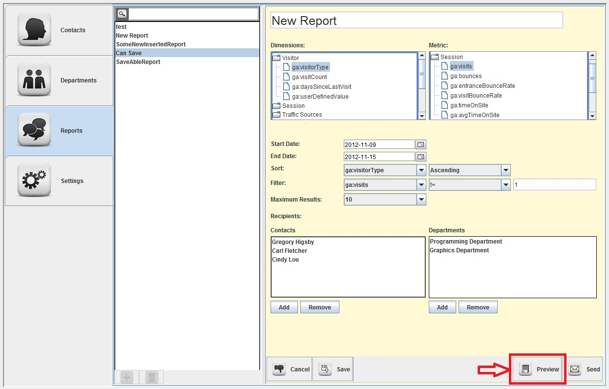

Figure 5

1. Click the “Close” button to close the preview window.

#### Previewing in Edit Mode

1. Select the Reports tab from the tab pane on the left side of the window.
2. Click the H:\EECS448\Project3+\EECS448_Project1\src\resources\images\plus.png (“Create”) button at the bottom of the list pane, or select an existing report from the list pane and click “Edit” in the bottom of the details pane.
3. Adjust the start and end dates, dimensions, metrics, sort, filter, and maximum results fields as desired.
   1. At least one dimensions or metric must be selected, but attempting to select more than the maximum of ten dimensions and metrics will result in an error dialog.
   2. A red field indicates an invalid value, which should be corrected before proceeding.
4. Click the H:\EECS448\Project3+\EECS448_Project1\src\resources\images\loadTiny.png(“Preview”) button at the bottom of the details pane. A pop-up window will appear showing the report results.
5. Click the “Close” button to close the preview window.
6. Click the H:\EECS448\Project3+\EECS448_Project1\src\resources\images\thumbsDownTiny.png (“Cancel”) button to discard the new report or changes to the existing report.  
   *Note*: The report can also be saved or updated by clicking the H:\EECS448\Project3+\EECS448_Project1\src\resources\images\save.png (“Save”) button.

### Sending a Report

Not yet implemented.

# The Settings Tab

Not yet implemented.

# Troubleshooting

**New contacts will not save to the database**

1. Double-check that there are no invalid values in the new contact form. These fields will be colored red. You must supply a contact name to save the contact.
2. Ensure that you are still connected to the database. This can be done by selecting another tab and checking whether or not you can view an item in another tab.

**New departments will not save to the database**

1. Double-check that there are no invalid values in the new department form. These fields will be colored red. You must supply a department name to save the department. The department must also have at least one employee in order to be saved.
2. Ensure that you are still connected to the database. This can be done by selecting another tab and checking whether or not you can view an item in another tab.

**New reports will not save to the database**

1. Double-check that there are no invalid values in the new report form. These fields will be colored red. You must supply a report name to save the report. The report must also have at least one dimension or metric selected in order to be saved.
2. Ensure that you are still connected to the database. This can be done by selecting another tab and checking whether or not you can view an item in another tab.

**The program is unable to connect to the database server**

1. Check your username, password, and database path in the database properties file.
2. Ensure that you have permissions to access the database.
3. Run the SQL commands in the database setup file to ensure that the database is using the required format.

**The program is unable to connect to Google Analytics**

1. Ensure that your username and password is correct when accessing Google Analytics.
2. Ensure that your username has the correct permissions to access Google Analytics for the desired website.

# Appendix A

A complete list of the names and descriptions of the dimensions and metrics that are supported by Google Analytics can be found online at:

<https://developers.google.com/analytics/devguides/reporting/core/dimsmets>

For ease of reference, the tables in this section detail all of the dimensions and metrics available inside the program. The source used to generate these tables is available online at:

<http://ga-dev-tools.appspot.com/explorer/>

## Dimensions

|  |  |  |
| --- | --- | --- |
| **Dimension Type** | **Dimension** | **Definition** |
| Visitor | visitorType | A boolean indicating if a visitor is new or returning. Possible values: New Visitor, Returning Visitor. |
| visitCount | The visit index for a visitor to your website. Each visit from a unique visitor will get its own incremental index starting from 1 for the first visit. Subsequent visits do not change previous visit indicies. For example, if a certain visitor has 4 visits to your website, ga:visitCount for that visitor will have 4 distinct values of '1' through '4'. |
| daysSinceLastVisit | The number of days elapsed since visitors last visited your website. Used to calculate visitor loyalty. |
| userDefinedValue | The value provided when you define custom visitor segments for your website. |
| Session | visitLength | The length of a visit to your website measured in seconds and reported in second increments. The value returned is a string. |
| Traffic Sources | referralPath | The path of the referring URL (e.g. document.referrer). If someone places a link to your website on their website, this element contains the path of the page that contains the referring link. |
| campaign | When using manual campaign tracking, the value of the utm\_campaign campaign tracking parameter. When using AdWords autotagging, the name(s) of the online ad campaign that you use for your website. Otherwise the value (not set) is used. |
| source | The source of referrals to your website. When using manual campaign tracking, the value of the utm\_source campaign tracking parameter. When using AdWords autotagging, the value is google. Otherwise the domain of the source referring the visitor to your website. (e.g. document.referrer). The value may also contain a port address. If the visitor came to the site without a referrer, the value is (direct) |
| medium | The type of referrals to your website. When using manual campaign tracking, the value of the utm\_medium campaign tracking parameter. When using AdWords autotagging, the value is ppc. If the user comes from a search engine detected by Google Analytics, the value is organic. If the referrer is not a search engine, the value is referral. If the visitor came directly to the site, and document.referrer is empty, the value is (none). |
| keyword | When using manual campaign tracking, the value of the utm\_term campaign tracking parameter. When using AdWords autotagging or if a visitor used organic search to reach your website, the keywords used by visitors to reach your website. Otherwise the value is (not set). |
| adContent | When using manual campaign tracking, the value of the utm\_content campaign tracking parameter. When using AdWords autotagging, the first line of the text for your online Ad campaign. If you are using mad libs for your AdWords content, this field displays the keywords you provided for the mad libs keyword match. Otherwise the value is (not set) |
| socialNetwork | Name of the social network. This can be related to the referring social network for traffic sources, or to the social network for social data hub activities. E.g. Google+, Blogger, reddit, etc. |
| hasSocialSourceReferral | Indicates visits that arrived to the site from a social source (i.e. A social network such as Google+, Facebook, Twitter, etc.). The possible values are Yes or No where the first letter is capitalized. |
| Platform/Device | browser | The names of browsers used by visitors to your website. For example, Internet Explorer or Firefox. |
| browserVersion | The browser versions used by visitors to your website. For example, 2.0.0.14 |
| operatingSystem | The operating system used by your visitors. For example, Windows, Linux , Macintosh, iPhone, iPod. |
| operatingSystemVersion | The version of the operating system used by your visitors, such as XP for Windows or PPC for Macintosh. |
| isMobile | Indicates mobile visitors. The possible values are Yes or No where the first letter must be capitalized. |
| mobileDeviceBranding | Mobile manufacturer or branded name (e.g: Samsung, HTC, Verizon, T-Mobile). |
| mobileDeviceModel | Mobile device model (e.g.: Nexus S) |
| mobileInputSelector | Selector used on the mobile device (e.g.: touchscreen, joystick, clickwheel, stylus). |
| mobileDeviceInfo | The branding, model, and marketing name used to identify the mobile device. |
| Geo/Network | continent | The continents of website visitors, derived from IP addresses. |
| subContinent | The sub-continent of website visitors, derived from IP addresses. For example, Polynesia or Northern Europe. |
| country | The countries of website visitors, derived from IP addresses. |
| region | The region of website visitors, derived from IP addresses. In the U.S., a region is a state, such as New York. |
| metro | The Designated Market Area (DMA) from where traffic arrived on your site. |
| city | The cities of website visitors, derived from IP addresses. |
| latitude | The approximate latitude of the visitor's city. Derived from IP address. Locations north of the equator are represented by positive values and locations south of the equator by negative values. |
| longitude | The approximate longitude of the visitor's city. Derived from IP address. Locations east of the meridian are represented by positive values and locations west of the meridian by negative values. |
| networkDomain | The domain name of the ISPs used by visitors to your website. This is derived from the domain name registered to the IP address. |
| networkLocation | The name of service providers used to reach your website. For example, if most visitors to your website come via the major service providers for cable internet, you will see the names of those cable service providers in this element. |
| System | flashVersion | The versions of Flash supported by visitors' browsers, including minor versions. |
| javaEnabled | Indicates Java support for visitors' browsers. The possible values are Yes or No where the first letter must be capitalized. |
| language | The language provided by the HTTP Request for the browser. Values are given as an ISO-639 code (e.g. en-gb for British English). |
| screenColors | The color depth of visitors' monitors, as retrieved from the DOM of the visitor's browser. For example 4-bit, 8-bit, 24-bit, or undefined-bit. |
| screenResolution | The screen resolution of visitors' monitors, as retrieved from the DOM of the visitor's browser. For example: 1024x738. |
| Page Tracking | hostname | The hostname from which the tracking request was made. |
| pagePath | A page on your website specified by path and/or query parameters. Use in conjunction with ga:hostname to get the full URL of the page. |
| pagePathLevel1 | This dimension rolls up all the page paths in the first hierarchical level in ga:pagePath. |
| pagePathLevel2 | This dimension rolls up all the page paths in the second hierarchical level in ga:pagePath. |
| pagePathLevel3 | This dimension rolls up all the page paths in the third hierarchical level in ga:pagePath. |
| pagePathLevel4 | This dimension rolls up all the page paths in the fourth hierarchical level in ga:pagePath. All additional levels in the ga:pagePath hierarchy are also rolled up in this dimension. |
| pageTitle | The title of a page. Keep in mind that multiple pages might have the same page title. |
| landingPagePath | The first page in a user's session, or landing page. |
| secondPagePath | The second page in a user's session. |
| exitPagePath | The last page in a user's session, or exit page. |
| previousPagePath | A page on your website that was visited before another page on your website. Typically used with the ga:nextPagePath dimension. |
| nextPagePath | A page on your website that was visited after another page on your website. Typically used with the ga:previousPagePath dimension. |
| pageDepth | The number of pages visited by visitors during a session (visit). The value is a histogram that counts pageviews across a range of possible values. In this calculation, all visits will have at least one pageview, and some percentage of visits will have more. |
| Internal Search | searchUsed | A boolean to distinguish whether internal site search was used in a session. Values are Visits With Site Search and Visits Without Site Search. |
| searchKeyword | Search terms used by website visitors on your internal site search. |
| searchKeywordRefinement | Subsequent keyword search terms or strings entered by users after a given initial string search. |
| searchCategory | The categories used for the internal search if you have this enabled for your profile. For example, you might have product categories such as electronics, furniture, or clothing. |
| searchStartPage | A page where the user initiated an internal site search. |
| searchDestinationPage | A page that the user visited after performing an internal website search. |
| Time | date | The date of the visit. An integer in the form YYYYMMDD. |
| year | The year of the visit. A four-digit year from 2005 to the current year. |
| month | The month of the visit. A two digit integer from 01 to 12. |
| week | The week of the visit. A two-digit number from 01 to 53. Each week starts on Sunday. |
| day | The day of the month. A two-digit number from 01 to 31. |
| hour | A two-digit hour of the day ranging from 00-23 in the timezone configured for the account. This value is also corrected for daylight savings time, adhering to all local rules for daylight savings time. If your timezone follows daylight savings time, there will be an apparent bump in the number of visits during the change-over hour (e.g. between 1:00 and 2:00) for the day per year when that hour repeats. A corresponding hour with zero visits will occur at the opposite changeover. (Google Analytics does not track visitor time more precisely than hours.) |
| nthMonth | Index for each month in the specified date range. Index for the first month in the date range is 0, 1 for the second month, and so on. The index corresponds to ga:month entries. |
| nthWeek | Index for each week in the specified date range. Index for the first week in the date range is 0, 1 for the second week, and so on. The index corresponds to ga:week entries. |
| nthDay | Index for each day in the specified date range. Index for the first day (i.e., start-date) in the date range is 0, 1 for the second day, and so on. |
| dayOfWeek | The day of the week. A one-digit number from 0 (Sunday) to 6 (Monday). |

## Metrics

|  |  |  |
| --- | --- | --- |
| **Metric Type** | **Metric** | **Definition** |
| Visitor | visitors | Total number of visitors to your website for the requested time period. |
| newVisits | The number of visitors whose visit to your website was marked as a first-time visit. |
| percentNewVisits | (ga:newVisits / ga:visits) \* 100 The percentage of visits by people who had never visited your site before. |
| Session | visits | Counts the total number of sessions. |
| bounces | The total number of single page (or single engagement hit) sessions to your website. |
| entranceBounceRate | (ga:bounces / ga:entrances) \* 100 The percentage of single-page visits (i.e. visits in which the person left your site from the entrance page). |
| visitBounceRate | (ga:bounces / ga:visits) \* 100 The percentage of single-page visits (i.e., visits in which the person left your site from the first page). |
| timeOnSite | The total duration of visitor sessions represented in total seconds. |
| avgTimeOnSite | ga:timeOnSite / ga:visits The average duration visitor sessions represented in total seconds. |
| Traffic Sources | organicSearches | The number of organic searches that happened within a session. This metric is search engine agnostic. |
| Page Tracking | entrances | The number of entrances to your website measured as the first pageview in a session. Typically used with ga:landingPagePath |
| entranceRate | (ga:entrances / ga:pageviews) \* 100 The percentage of pageviews in which this page was the entrance. |
| pageviews | The total number of pageviews for your website. |
| pageviewsPerVisit | ga:pageviews / ga:visits The average number of pages viewed during a visit to your site. Repeated views of a single page are counted. |
| uniquePageviews | The number of different (unique) pages within a session. This takes into both the pagePath and pageTitle to determine uniqueness. |
| timeOnPage | How long a visitor spent on a particular page in seconds. Calculated by subtracting the initial view time for a particular page from the initial view time for a subsequent page. Thus, this metric does not apply to exit pages for your website. |
| avgTimeOnPage | ga:timeOnPage / (ga:pageviews - ga:exits) The average amount of time visitors spent viewing this page or a set of pages. |
| exits | The number of exits from your website. |
| exitRate | (ga:exits / ga:pageviews) \* 100 The percentage of site exits that occurred out of the total page views. |
| Internal Search | searchResultViews | The number of times a search result page was viewed after performing a search. |
| searchUniques | The total number of unique keywords from internal site search within a session. For example if "shoes" was searched for 3 times in a session, it will be only counted once. |
| avgSearchResultViews | ga:searchResultViews / ga:searchUniques The average number of times people viewed a search results page after performing a search. |
| searchVisits | The total number of sessions that included an internal site search |
| percentVisitsWithSearch | (ga:searchVisits / ga:visits) \* 100 The percentage of visits with search. |
| searchDepth | The average number of subsequent page views made on your site after a use of your internal search feature. |
| avgSearchDepth | ga:searchDepth / ga:searchUniques The average number of pages people viewed after performing a search on your site. |
| searchRefinements | The total number of times a refinement (transition) occurs between internal site search keywords within a session. For example if the sequence of keywords is: "shoes", "shoes", "pants", "pants", this metric will be one because the transition between "shoes" and "pants" is different. |
| searchDuration | The visit duration to your site where a use of your internal search feature occurred. |
| avgSearchDuration | ga:searchDuration / ga:searchUniques The average amount of time people spent on your site after searching. |
| searchExits | The number of exits on your site that occurred following a search result from your internal search feature. |
| searchExitRate | (ga:searchExits / ga:searchUniques) \* 100 The percentage of searches that resulted in an immediate exit from your site. |
| searchGoal(n)ConversionRate | (ga:goal(n)Completions / ga:searchUniques) \* 100 The percentage of search visits (i.e., visits that included at least one search) which resulted in a conversion to the requested goal number |
| SearchGoalConversionRateAll | (ga:goalCompletionsAll / ga:searchUniques) \* 100 The percentage of search visits (i.e., visits that included at least one search) which resulted in a conversion to at least one of your goals. |
| goalValueAllPerSearch | ga:goalValueAll / ga:searchUniques The average goal value of a search on your site. |
| Site Speed | pageLoadTime | Total Page Load Time is the amount of time (in milliseconds) it takes for pages from the sample set to load, from initiation of the pageview (e.g. click on a page link) to load completion in the browser. |
| pageLoadSample | The sample set (or count) of pageviews used to calculate the average page load time. |
| avgPageLoadTime | (ga:pageLoadTime / ga:pageLoadSample) \* 0.001 The average amount of time (in seconds) it takes for pages from the sample set to load, from initiation of the pageview (e.g. click on a page link) to load completion in the browser. |
| domainLookupTime | (ga:domainLookupTime / ga:speedMetricsSample) \* 0.001 The average amount of time (in seconds) spent in DNS lookup for this page. |
| avgDomainLookupTime | (ga:domainLookupTime / ga:speedMetricsSample) \* 0.001 The average amount of time (in seconds) spent in DNS lookup for this page. |
| pageDownloadTime | The total amount of time (in milliseconds) to download this page among all samples. |
| avgPageDownloadTime | (pageDownloadTime / ga:speedMetricsSample) \* 0.001 The average amount of time (in seconds) to download this page. |
| redirectionTime | The total amount of time (in milliseconds) spent in redirects before fetching this page among all samples. If there are no redirects, the value for this metric is expected to be 0. |
| avgRedirectionTime | (ga:redirectionTime / ga:speedMetricsSample) \* 0.001 The average amount of time (in seconds) spent in redirects before fetching this page. If there are no redirects, the value for this metric is expected to be 0. |
| serverConnectionTime | The total amount of time (in milliseconds) spent in establishing TCP connection for this page among all samples. |
| avgServerConnectionTime | (ga:serverConnectionTime / ga:speedMetricsSample) \* 0.001 The average amount of time (in seconds) spent in establishing TCP connection for this page. |
| serverResponseTime | The total amount of time (in milliseconds) your server takes to respond to a user request among all samples, including the network time from user's location to your server. |
| avgServerResponseTime | (ga:serverResponseTime / ga:speedMetricsSample) \* 0.001 The average amount of time (in seconds) your server takes to respond to a user request, including the network time from user's location to your server. |
| speedMetricsSample | The sample set (or count) of pageviews used to calculate the averages for site speed metrics. This metric is used in all site speed average calculations including ga:avgDomainLookupTime, ga:avgPageDownloadTime, ga:avgRedirectionTime, ga:avgServerConnectionTime, and ga:avgServerResponseTime. |
| Exception Tracking | exceptions | The number of exceptions that were sent to Google Analytics. |
| fatalExceptions | The number of exceptions where isFatal is set to true. |